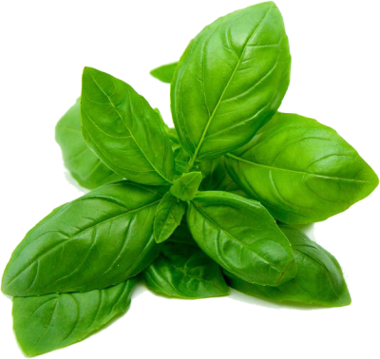

**Basil Varieties for Your Garden**

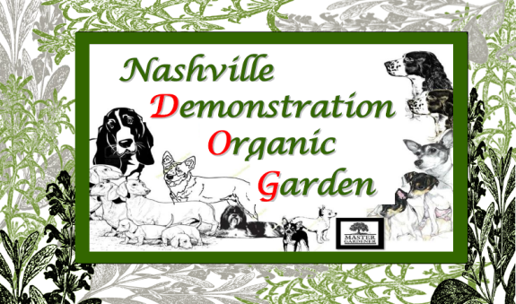













**Basil is one of the most widely used herbs, with many varieties and cultivars, offering varying flavors suited to particular ethnic dishes, including pesto, pasta sauces, Thai curries and much more. Basil possibly originated in India and has been cultivated there at least 5,000 years. Basil is a good source of vitamin A, flavanoids and antioxidants and has been shown to have antioxidant, anticancer, antiviral, and antimicrobial properties. In India it is traditionally used to treat stress, asthma and diabetes.**

**Lore The word basil is derived from the Greek word basileus meaning “royal” or “kingly.” Ancient Greek and Romans associated basil with hatred and believed it would grow only if the seeds were sowed while screaming wild curses. However, later in Italy and elsewhere, basil was a symbol of love. In the Victorian language of flowers basil was used to convey the sender’s best wishes, but could also signify hatred. In India, basil has religious significance and the Hindu religion associates holy basil with purification, protection, love and eternal life. Hindus used holy basil in burial rituals and devout Hindus may sleep with a basil leaf on their chest, as a passport to Paradise. In the Christian tradition, basil is said to have grown at the site of Christ’s crucifixion and is part of the St. Basil feast day celebrations in Greece on January 1st.**

Sweet Basil (*Ocimum basilicum*) is the most widely grown basil in the United States and there are many varieties. The taste is sweet, floral and delicate, with slightly minty notes, an anise-like aroma and clove-like undertones.

Genovese Basil (*Ocimum basilicum* ‘Genovese’) is a cultivar of sweet basil and is one of the most popular basils for culinary use. Genovese basil has a reputation for making the best pesto, as well as the best "insalata caprese," which is dish consisting of tomato slices topped with mozzarella cheese and fresh basil leaves.

Opal Basil (*Ocimum basilicu’Dark Opal’*) is a cultivar of sweet basil, also known as purple-leaf basil. It is often grown as an ornamental addition for the garden or for a dramatic culinary presentation. Opal basil is sweetly pungent with a mild flavor and hints of ginger. It is versatile, adding color and flavor to a wide variety of recipes. Try adding opal basil and edible flowers to create a colorful mixed green salad.

**Cinnamon Basil** *(Ocimum basilicum’Cinnamon) as used here refers to a cultivar of sweet basil. (“Cinnamon basil” also be used as a synonym for Thai basil or may refer to a particular variety of Thai basil.)* Cinnamon basil, has a spicy, fragrant aroma and flavor and contains methyl cinnamate, the same chemical that gives cinnamon its flavor.

**Thai Basil** **(***Ocimum basilicum* var. *thyrsiflora* ) Thai basil is a variety of sweet that has been cultivated to provide distinctive traits. Widely used throughout Southeast Asia, its anice or licorice flavor, is more stable under high or extended cooking temperatures than that of sweet basil.

Lime Basil - (*Ocimum americanum* ‘Lime’) is a cultivar of African basil, *Ocimum americanum*. Similar to lemon basil, but with a tangy lime flavor and fragrance. Use lime basil to flavor fish and chicken dishes, vinegars, dressings, fruit salsas, chutneys, sauces, herb teas and herb oils. Great accompaniment with broiled or grilled fish or shellfish, or in traditional Thai dishes when Lemongrass or Kaffir Lime isn't readily available.

Lemon Basil - (*Ocimum* × *citriodorum*), also called Thai lemon basil or Lao basil. Lemon basil is a hybrid between sweet basil (Ocimum basilicum) and African basil (Ocimum americanum). It is primarily grown in northeastern Africa and southern Asia. Lemon basil is known for its distinct lemon aroma that is especially pungent once it is minced or cooked. Lemon basil is mild enough to flavor grilled fish or shrimp and can be substituted for basil if you are looking for a fresh twist of flavor.  Finely chop and add it to pasta with julienne vegetables and a flavorful extra virgin olive oil for a light and delicious meal.  Cooking with lemon basil is fun and easy, as there are no rules—just add to any of your favorite recipes. Lemon basil is often used in Indonesian and Thai Cuisines

**African Blue Basil** (*[Ocimum kilimandscharicum](http://en.wikipedia.org/wiki/Ocimum_kilimandscharicum" \o "Ocimum kilimandscharicum)* × *basilicum* '[Dark Opal](http://en.wikipedia.org/wiki/Dark_opal_basil)') is a hybrid of camphor basil and Dark Opal basil and one of the few basils that is perennial. As a hybrid, African Blue Basil is unable to produce seeds of its own, and is propagated by cuttings. It blooms profusely like an annual, but being sterile does not go to seed. It is also taller than many basil cultivars. These blooms are beautiful in arrangements and excellent at attracting bees and other pollinators.

It has similarities to both Thai and sweet basil, yet has a flavor all its own. Its long, pink flowers also make a striking garnish. Not widely used as a culinary herb, but may be used as the other basils and can add a complexity to the dish, tasting like more than one herb has been used.

**Cooking Tips**

Most basils should be used fresh and added during the last moments of cooking.  Over cooking basil will result in loss of flavor. Incorporate the whole leaf or mince finely with a sharp kitchen knife, depending on your recipe. When substituting fresh herbs in a recipe calling for dry, one part dry is equal to three parts fresh.

**Visit Nashville Demonstration Garden, NDOG, each Friday May through September during market hours.**

**Check out the Howard County Farmers’ Market pages at** **nashvillear.com** **and at** [**nashvilleghc.com**](nashvilleghc.com) **for updates on what is happening in the garden and expected at market or contact Market Manager Debra Bolding at (870) 557-2352 or NDOG Coordinator Gerry Wenta at (903) 278-6716 for more information.**